+

Backround:

* Clear cutting is a forestry management practice in which most or all trees are uniformly cut down.
* Clear cutting is primarily used for timber harvest however its practice can also be beneficial for forest preservation. An example can be to protect trees from diseases such as dothistroma needle blight on pine trees.
* In the Glenmore forest, clear cutting was used to remove non native species, specifically dothistorma infected logepole pine. [reference](https://parkswatchscotland.co.uk/2023/04/18/native-pinewood-restoration-in-the-cairngorms-fls-botched-experiment-at-the-heart-of-glenmore/)
* However in their efforts to restore native pine species, clear cutting has accelerated the loss of soil organic matter, nutrients and water uptake of vegetation while increasing surface run off and nutrient leaching.
* A key nutrient is phosphorus where its increase in nearby water catchment areas can alter the chemical composition of the water, resulting in eutrophication.
* Phosphorus is already a limiting nutrient for plants thus its decrease can have lasting impacts on phosphorus retention in soil.
* Clear cutting also affects pH, its alkaline state is important for soil health and structure, as low pH can impact the rate of nutrient and water intake and therefore vegetation growth.
* To combat phosphorus loss, an iron oxide rich material called Ochre, which is a result of acid mine drainage, can immobilise phosphorus through the formation of stable iron phosphorus complexes. This reduces phosphorus mobility and promotes soil retention, reducing eutrophication risk and continuting to soil nutrient stability.
* As a result our project is focusing on how to reduce the loss of phosphorus in these soils with the use of ochre.

Iron oxide rich Ochre = formation of stable iron phosphorus complexes ->binds to phosphorus + immobilise phosphorus = promoting soil retention + reduces eutrophication + increasing soil stability.

Key questions

* Is iron ochre effective at increasing phosphorus retention in clear cut forest sites?
* At what level is the treatment most effective
* Up to what concentration of phosphorus
* Does pH have an effect on the retention of phosphorus on amended soils?
* Is iron ochre effective at increasing phosphorus retention in clear-cut forest soils?
* At which phosphorus concentrations and ochre treatment levels is retention most effective?
* How does soil pH influence phosphorus retention in ochre-amended soils?

Stuff that James said:

(The iron oxide is) Amphoteric – able to react both as a base and an acidic. When it's an acid it has positives around it meaning that the phosphate is attracted to it because it is negatively charged. If there is a negative charge already but there is a lot of phosphate it will knock off other negatively charged things like chloride and bind to the positive charges to try and reach an equilibrium.

Methods:

<https://www.aces.edu/blog/topics/crop-production/understanding-phosphorus-forms-and-their-cycling-in-the-soil/>

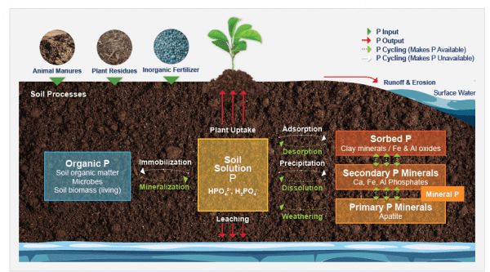

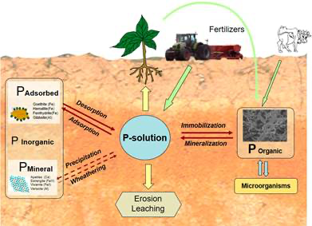

See prev posters below:

**Phosphate loading solution and percent phosphate sorption have a negative relationship of -0.37 (F(1,58)=15.67,p<0.01)**

Iron ochre and percent phosphate sorption have a positive relationship of 3.82 (f(1,58)=44.04,p<0.01)

pH level and percent phosphate sorption have a negative relationship of -0.15

(f(1,13)=17.88, p<0.01)

|  |  |
| --- | --- |
|  | Estimates |
| Iron ochre amendment (%) | 3.82*** |
| Phosphate loading  Concentration (ml/L) | -0.371*** |

